Linear regression results:  
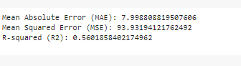

GradientBoostingRegressor() results:  
  
  
  
RandomForestRegressor results:  
  
  
RandomizedSearchCV results:  
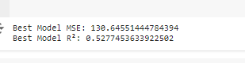

PolynomialFeatures results

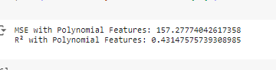

GridSearchCV results

